
J:\Sales\Product Information\Lifejackets & Accessories
Lifejacket inflation Systems
United Moulders Mk5 Automatic Inflator
The Automatic cartridge usually activates within 3 seconds. Has a fail-safe back of manual activation.
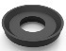
OSS5080 – UM Operating Head “O” Ring (Top & Bottom)
[UMO4009]

OSS5032 – UM Mk5 Auto Op Head c/w cartridge
‘D’ manifold fixing.
[UMS4012/C160]
{90-ISP-91A-030}

LIF3070 – UM Mk5 Auto Cartridge - Green Cap
[UMA5000]
{90-ISP-91X-053}

OSS5071 – UM Mk5 Op Head Flat gas seal
[IU-UM1601]

UM Bulletin changed the washer, which use to be
OSS5081 UM Gas Seal “O” Ring ½” [UMO0005]

LIF3082 – UM Mk5 (Y) Op Head Retaining Clip 13mm
[UMS4014A]
{90-ISP-91A-022}

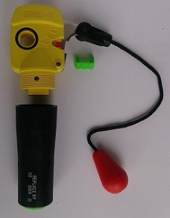
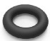

Standard Pull Cord Length 160mm. Other lengths available.

Available with either ‘D’ or ‘O’ manifold fixing attachments.

UNL Mk5 Inflator (Discontinued)
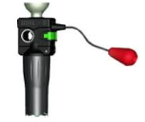
LIF3059 – UM Mk5 Black Op Head Retaining
Clip 17mm
[UM01622/C] {90-ISP-91X-020}

United Moulders Manual Inflators
OSS5061 - UM Micro Manual Operating Head (To fit D post Manifold) [UMA6020]

Launched by UML in 2017 to replace the Compact Mini Manual Inflator. Being 6mm Shorter & 15 grams lighter this new smaller, lightweight product is used in both Commercial and leisure lifejackets.

Available with either ‘D’ or ‘O’ manifold fixing attachments.

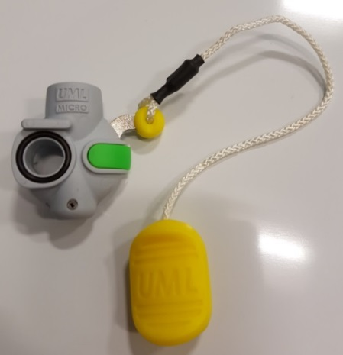
OSS5081 – UM Gas Seal “O” Ring ½”
[UMO0005]

OSS5080 – UM Operating Head “O” Ring (Top & Bottom)
[UMO4009]

LIF3082 – UM Mk5 (Y) Op Head Retaining Clip 13mm
[UMS4014A]
{90-ISP-91A-022}

Standard Pull Cord Length 160mm. Other lengths available.

OSS5060 – UM Mk2 Mini Manual Op Head [UMS1700/B]

OSS5081 – UM Gas Seal “O” Ring ½”
[UMO0005]

OSS5080 – UM Operating Head “O” Ring (Top & Bottom)

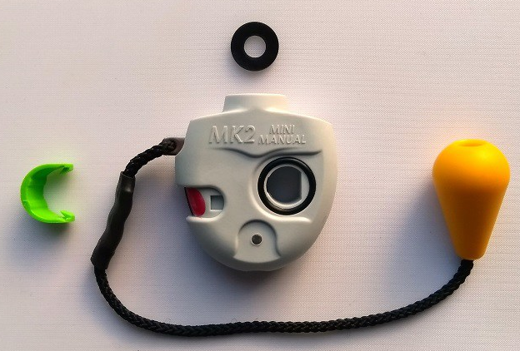

LIF3080 – UM Mini Op Head Retaining Clip, Curved
[UMS1622/1]
{90-ISP-91X-021}

UM Manual Operating Heads Discontinued.
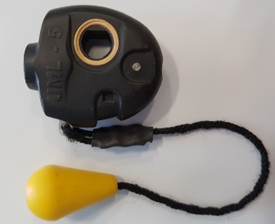
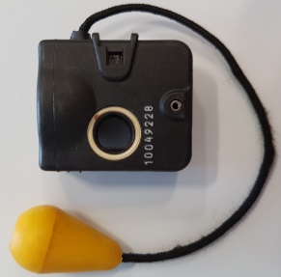
LIF3030 - UM Mk5 Manual UM Manual Operating head.
Op Head
[UM1600] LIF3059 - Retaining clip
{1-90-ISP 91X-050}

United Moulders Pro Sensor inflator
OSS5034 – UM Pro Sensor Auto Op Head c/w cartridge

United Moulders Pro Sensor Inflator Op Head and UMA 5001 Mk5i Cartridge with Black end cap.
OSS5081 – UM Pro Sensor Gas “O” Seal
[UMO0005]

OSS5080 – UM Operating Head “O” Ring (Top & Bottom)
[70-ISP-MIS-081]

Cylinder Indicator Window

Cartridge Indicator Window

LIF3074 – UM Pro Sensor Auto Cartridge - Black Cap
[UMA5001]

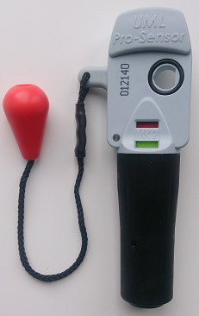

Standard Pull Cord 160mm.
Other lengths available

United Moulders Pro Sensor Manual Inflator

OSS5033 – UM Pro Sensor Manual Operating head
OSS5081 – UM Pro Sensor Gas “O” Seal
[UMO0005]

OSS5080 – UM Operating Head “O” Ring (Top & Bottom)
{70-ISP-MIS0081}

Cylinder Indicator Window

Standard Pull Cord 160mm
Other lengths available

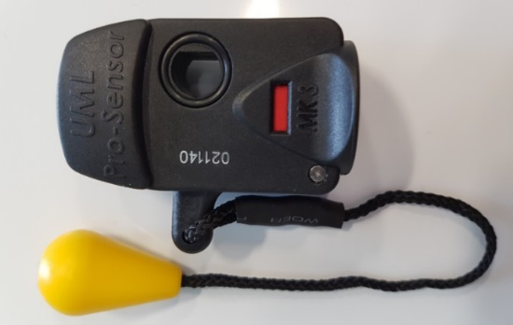

Pro Sensor Elite

Launched in 2017 the Pro Sensor Elite Automatic Inflator replaces the Pro Sensor Automatic sensor. It is 13mm shorter & 4 grams lighter, more rounder design & improved manual lever.

Inflators available with either ‘D’ or ’O’ manifold fixing attachment.
Only available in right hand pull version.

Standard Pull Cord 160mm.
Other lengths available

OSS5081 – UM Pro Sensor Gas “O” Seal
[UMO0005]

OSS5080 – UM Operating Head “O” Ring (Top & Bottom)
{70-ISP-MIS-081}


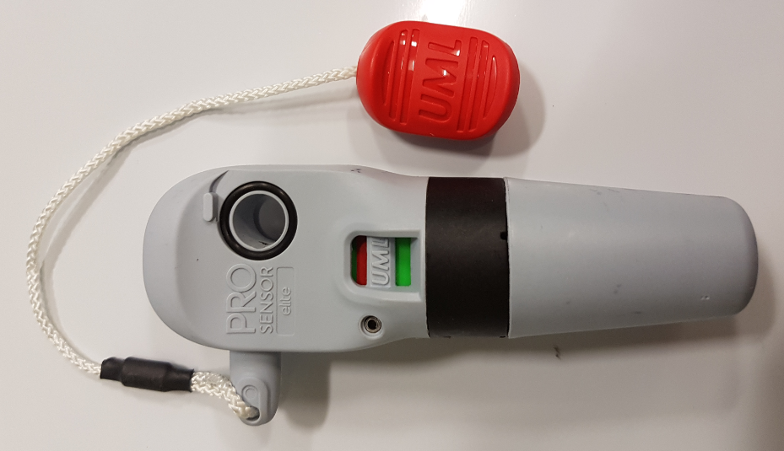
Cylinder Indicator window

Cartridge Indicator Window

The capsule is dated with replace
by date. (ie October 2017)
Leisure users change every 2 years

Commercial change capsule annual.
This capsule is not interchangeable with the Mk5 capsule.

If either wind is RED do not use.

OSS5037 - UM Pro Sensor Elite Operating Head (to fit D manifolds) [UMA8000]
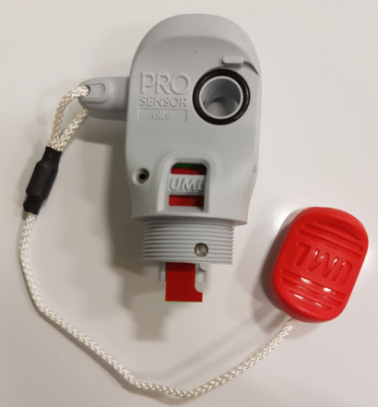
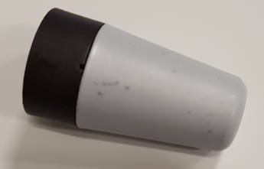
OSS5038 - UM Pro Sensor Elite Cartridge [UMA8050]

Halkey Roberts Alpha Inflator
OSS5500 – HR Alpha Automatic Operating Head c/w Spring Capsule [V90000TG60B]
OSS5017 - HR Alpha Op Head Middle “Square” Washer (Gas washer)
[V87403]

LIF3055 – HR Alpha Op Head Side Retaining Clip.
Also known as Dog/Frog clip
[V90124]
{90-ISP-91X-012}

OSS5502 – HR Alpha Inflation End Cap – [V90131G]
{90-ISP-91}

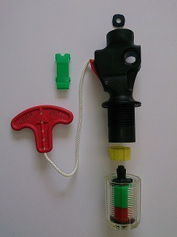
OSS5020 – HR Alpha Op Head Top Washer
[8491AMPK]
{90-ISP-01X-044}

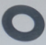 OSS5025 – HR Alpha Op Head Bottom Washer
[8492AMPK]
{90-ISP-91X-059}

LIF3050 – HR Super Bobbin
[V80040]
{90-ISP-91X-030}

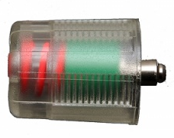

OSS5005 - HR Firing Spring Capsule - old version {90-ISP-91X-046}

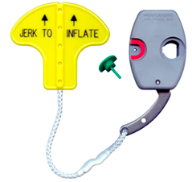
Halkey Roberts 840 Manual Inflator
OSS5005 – HR Manual Operating Head [840AMULEP55] {90-ISP-91X-021}
Standard Lanyards lengths 10, 13, 15cms, available in Ball or Pull Tab
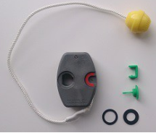
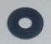 OSS5028 – HR Manual Op Head Middle Washer (Gas Washer)
[849AML]
{90-ISP-91X-048}

LIF3057 - HR Manual Op Head Side Retaining Clip
[8451AMAG]
{90-ISP-91X037}

V85006 HR Locking Pin
[V85006]
{90-ISP-91X-045} Discontinued

OSS5020 - HR Alpha Op Head Top Washer
[8491AM]
{90-ISP-91X-044}

OSS5025 - HR Alpha Op Head Bottom Washer
[8492AM]
{90-ISP-91X-059}

Inflation Head D Post
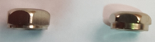
Brass D Post
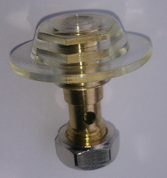
OSS5100 – UM Manifold Valve Nut
UMS1680 // 90-ISP-91X-015
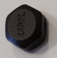
OSS5105 - UM Manifold Nut Cover-
Used to reduce potential abrasion
on the bladder
UMS1685
OSS5015 - HR Manifold Valve Nut
833AO1PK // 90-ISP91X-039
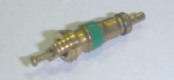
JON9999 - HR D Post Assembly Brass
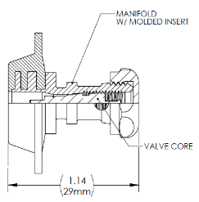
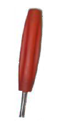
OSS5027 – Schrader Valve
OSL9554 – Tool – Shrader Valve Tool

Moulded D Post
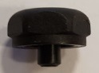
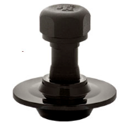
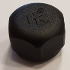
JON0351 - HR D Post Cap (Nut)
90-ISP-91X-102
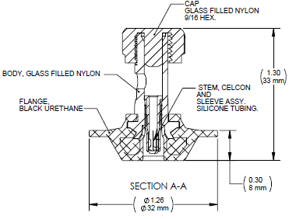
JON0350 – HR D Post moulded
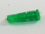
JON0355 – HR Sleeve & Stem Assy.

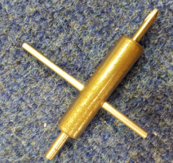
JON0352 – Tool HR Valve Composite Core
70-ISPSVR-009
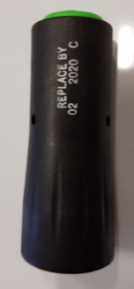
Dated parts Cylinders
Zinc coated CO2 with ½” UNF Thread

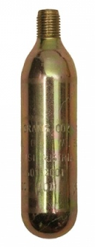
LIF3005 – 18g (Box 140)
LIF3010 – 24g (Box 140)
LIF3020 – 33g (Box 140)
LIF3025 – 38g (Box 96)
LIF3030 – 45g sprayed (Box TBC)
Cartridge shows Expiry Date LIF3035 – 60g (Box 60)
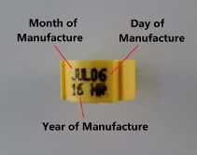
Info on cylinder:
Weight of CO2
Manufactures date
CO2 Cylinders do not show an expiry date.

Hammar Lifejacket Inflators
LIF3040
Hammar A1 Manual / Auto Front Plate
Standard handle
IA-0400

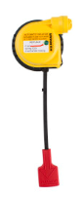
LIF3045
Hammar M1 Manual Inflator Front Plate
Standard Handle
Key provided
IM-0401

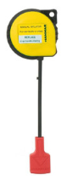

Hammar A1 / M1 Manual / Auto Front Plate
Short loop tail
IA-0410 {90-ISP-91A-055}

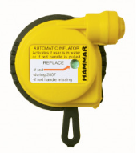
Hammar M1 Manual Inflator Front Plate
Short Loop Tail
IM-0405

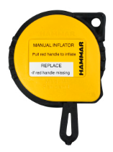

LIF3046
Hammar A1 / M1 Manual / Automatic Back Plate
Back Plate for A1 / M1
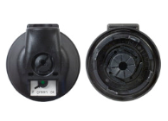
Standard Model
IB-0400

21-ISP-033-HHA Hammar A1 Back plates proved with 33g Cylinder
21-ISP-060-HHA Hammar A1 Back plates proved with 60g Cylinder

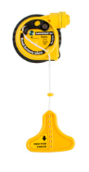
LIF3094
Hammar MA1 EC Manual / Auto Front Plate
Cord length 125mm
IA-0605

Hammar MA1 EC Manual / Auto Front Plate
Cord 94mm
IA-0600

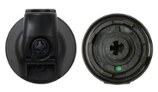

LIF3095
Hammar MA1 EC Manual / Auto Back Plate
Back Plate for MA1 EC
EC model
IB-0600 {90-ISP-91A-011}

21-ISP-033-HHB Hammar MA1 Back plates proved with 33g Cylinder
21-ISP-060-HHB Hammar MA1 Back plates proved with 60g Cylinder

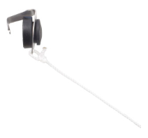
Manual Conversion Cap
Stops the automatic function while mounted
IA-0800

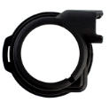
Hammar Rubber Bumper for MA1
Protection for Heavy user
IA-0900

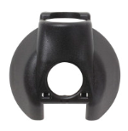

Hammar Protective Cover for Body
IB-0710

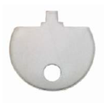
Hammar Inflator Opening Key
IT-0002
70-ISP-SRV-014

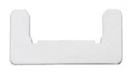

Hammar Service Key
IT-0009

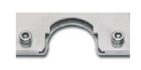

Hammar Cylinder Bracket (Bench Mount)
IT-0017
70-ISP-SVR-012

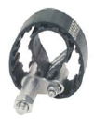

Hammar Cylinder Adaptor Tool (Torque Adaptor)
IT-0018
70-ISP-SVR-013

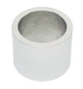
Hammar Welding Tool
Auminium
Used for samples & prototypes
IT-0010

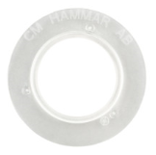
Sealing Ring
IT-0001

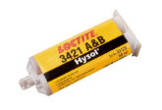
Loctite Cylinder Seal
Epoxi 3421
Including one mixing tube
IT-0027

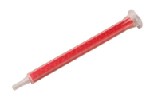

Loctite Automix-Mixing tube
IT-0028

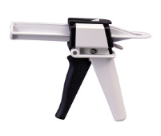

Loctite Teromix Gluegun
IT-0029

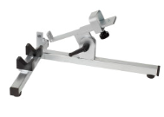

Glue Gun Holder
IT-0030

